Machine learning cybersecurity

Log file vectorization

LAB 1: Writing a script to vectorize log file
Lab Description: This lab is to vectorize the log files in order to get the features and labels for supervise learning.
Example of log file:
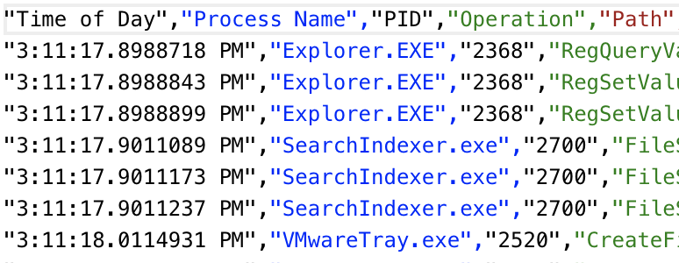
You are required to write a python script to vectorize the log files
Lab Environment:
- The students should have access to a machine with Linux system or Windows system
- The environment for python is required as well as some packages such as numpy, tensorflow, pandas and sklearn.

Lab Files that are Needed:
- For this lab you will need several log files, including the log files for normal activity and attack activity.

Lab exercise 1
- Import the required libraries.
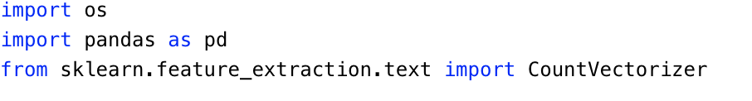
- Define the parameter to store the path for script to read data. And define the parameters to store the labels and text to be vectorized.
  - The name of the files will tell you whether it belongs to a normal activity or not.
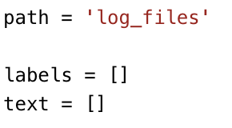
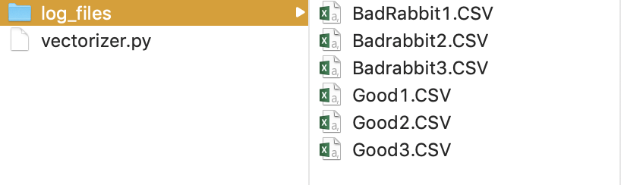

- Read the content from each file and create labels for them
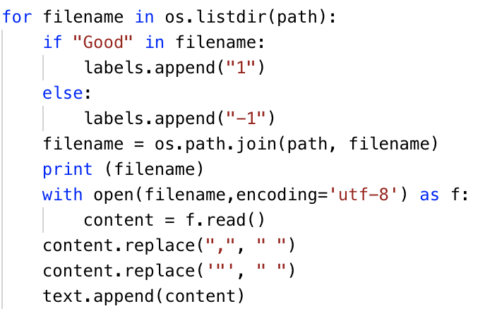
  - If the log file belongs to a normal activity, "1" will be assigned to it as a label. Otherwise, "-1" will be assigned to indicate it belongs to an attack activity.
  - In order to perform vectorization, some characters such as comma and quotation mark need to be removed.
- Use CountVectorizer() to create a vectorizer for the text of log files. After the vectorization, you will be able to get the features and feature names of the content.
- stop_words='english' indicates that all the stop words in the content will be removed.
- max_features=1000 indicates that 1000 features will be generated based on the frequency order of the terms in text.
- Save the features to a csv file by using pandas DataFrame.to_csv() function.
  - You may first need to covert the results to a dataframe
  - The index of dataframe should be the labels
  - Vectorizer can give you the names of the features, and you can use them as the column names for the dataframe.

What to Submit

You should submit a lab report file which includes:
  - The steps you processed data
  - The necessary code snippet of your vectorizer.
  - The screenshot of the results
  - You can name your report "Lab_logfile_vectorization_yourname.doc".

