Machine learning cybersecurity intrusion detection

LAB 1: Writing a classifier for kdd99 DATASET
Lab Description: This lab is to implement a binary classifier to distinguish normal connections from attacks. Since the dataset is a large dataset, you may need to employ GPU to run the code.
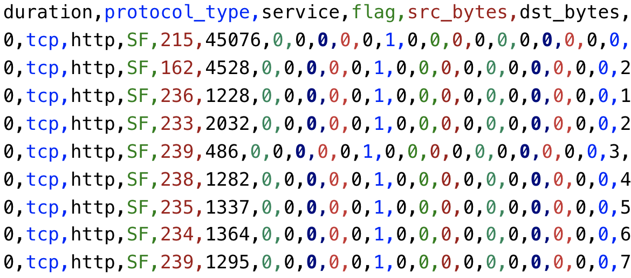
Lab Environment:
- The students should have access to a machine with Linux system
- The environment for python is required as well as some packages such as numpy, tensorflow and sklearn.
- GPU box

Lab Files that are Needed:
- For this lab you will need only one file (kdd.data.csv) for both WEKA and python script.
- The last column is the class value, others are the features.

Lab exercise 1
- In this exercise, you will implement an artificial neural network classifier based on Tensorflow
- Import the required libraries
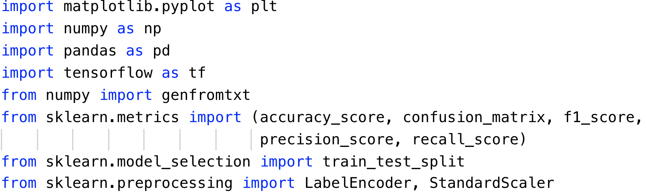
- Repeat the same steps to preprocess the data as Exercise 2. Read the data, standard scale the feature and encode the labels.
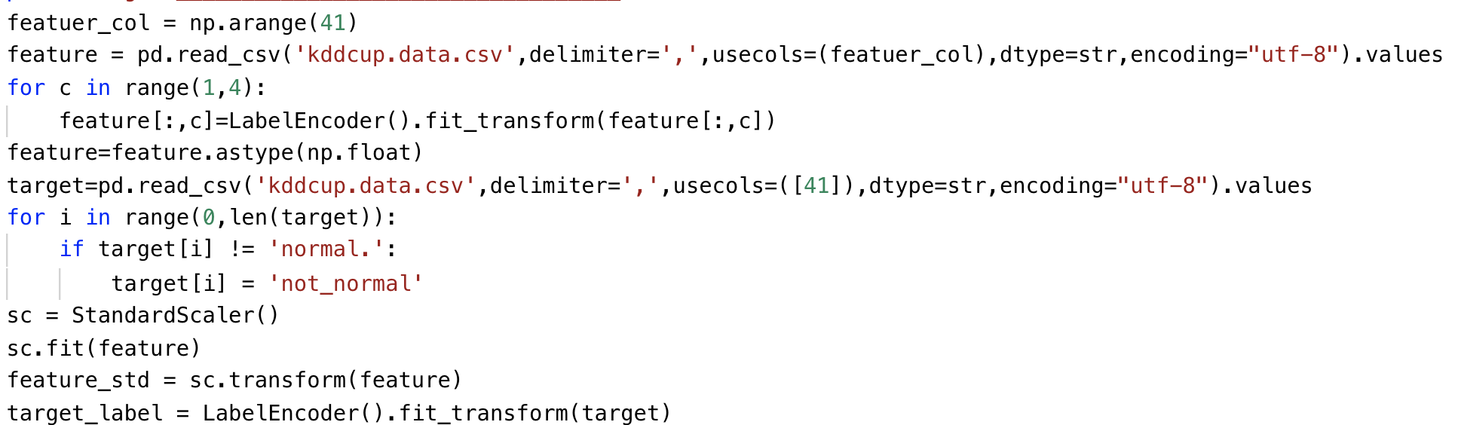
- Define the learning rate, number of epochs and batch size for artificial neural network
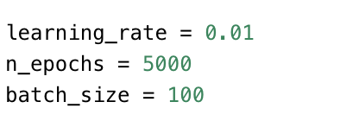
- An extra step in preprocess is to perform the one-hot encoding for the labels.
Since the type of result of tf.one_hot is a tensor object, it has to be converted to a numpy array.
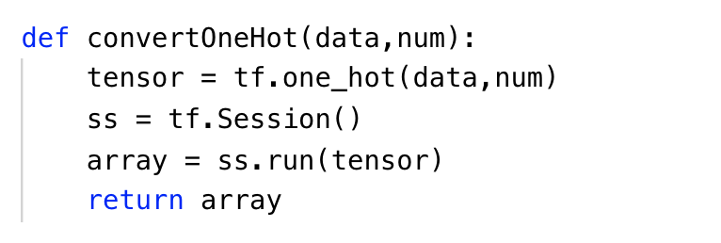

- Split the dataset after preprocessing and define the parameters to store the shape of placeholder.
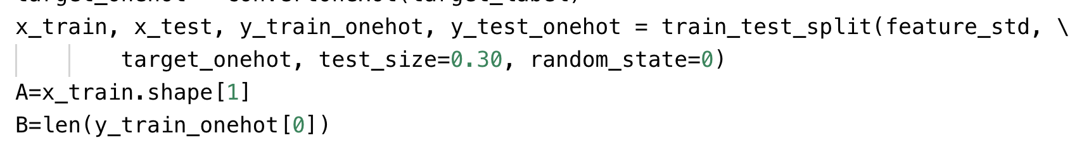
- Define the function to draw the plot of performance
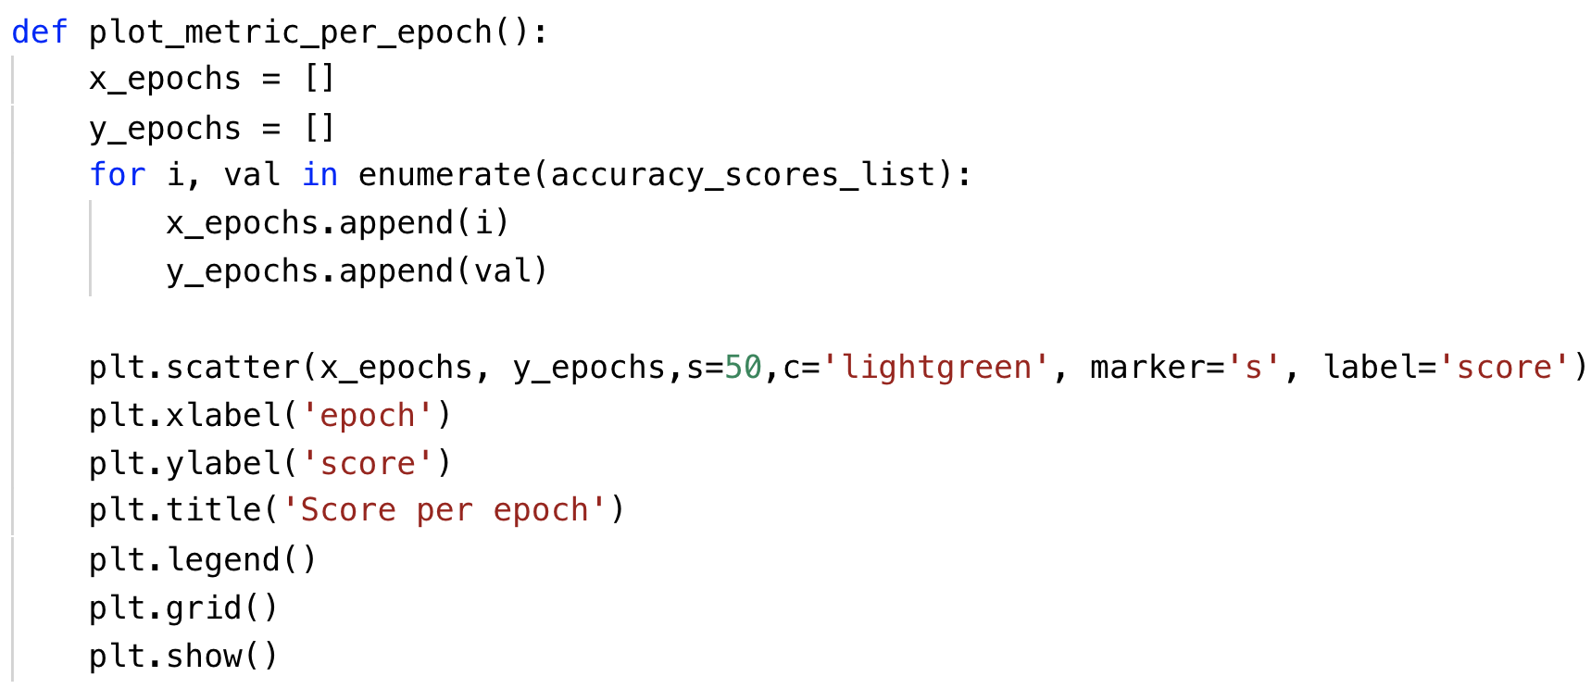
- Define your own architecture of neural network
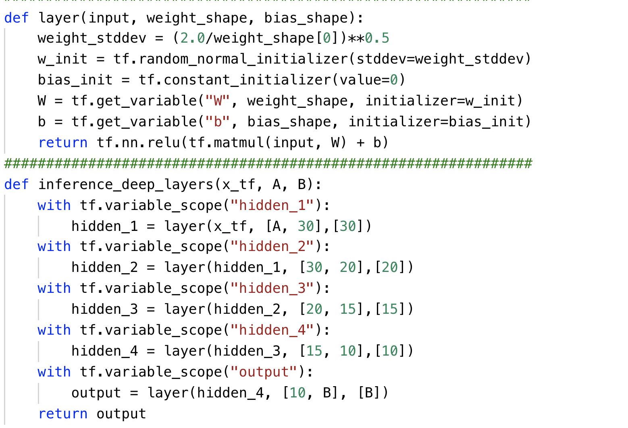
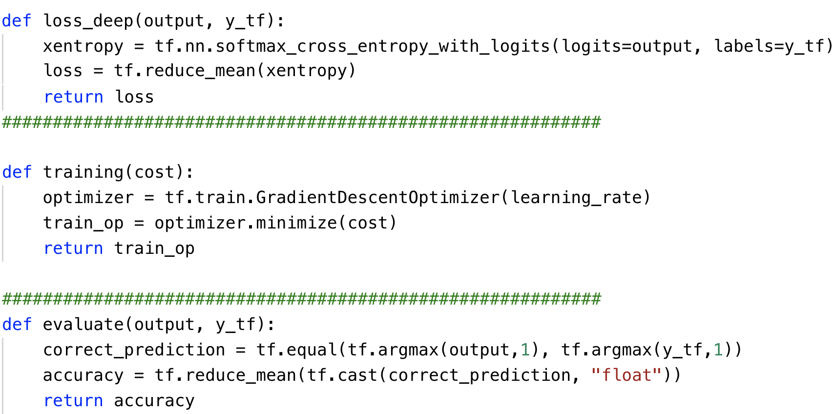
- Please print the statistics metrics such as accuracy, recall, precision and f1 score.
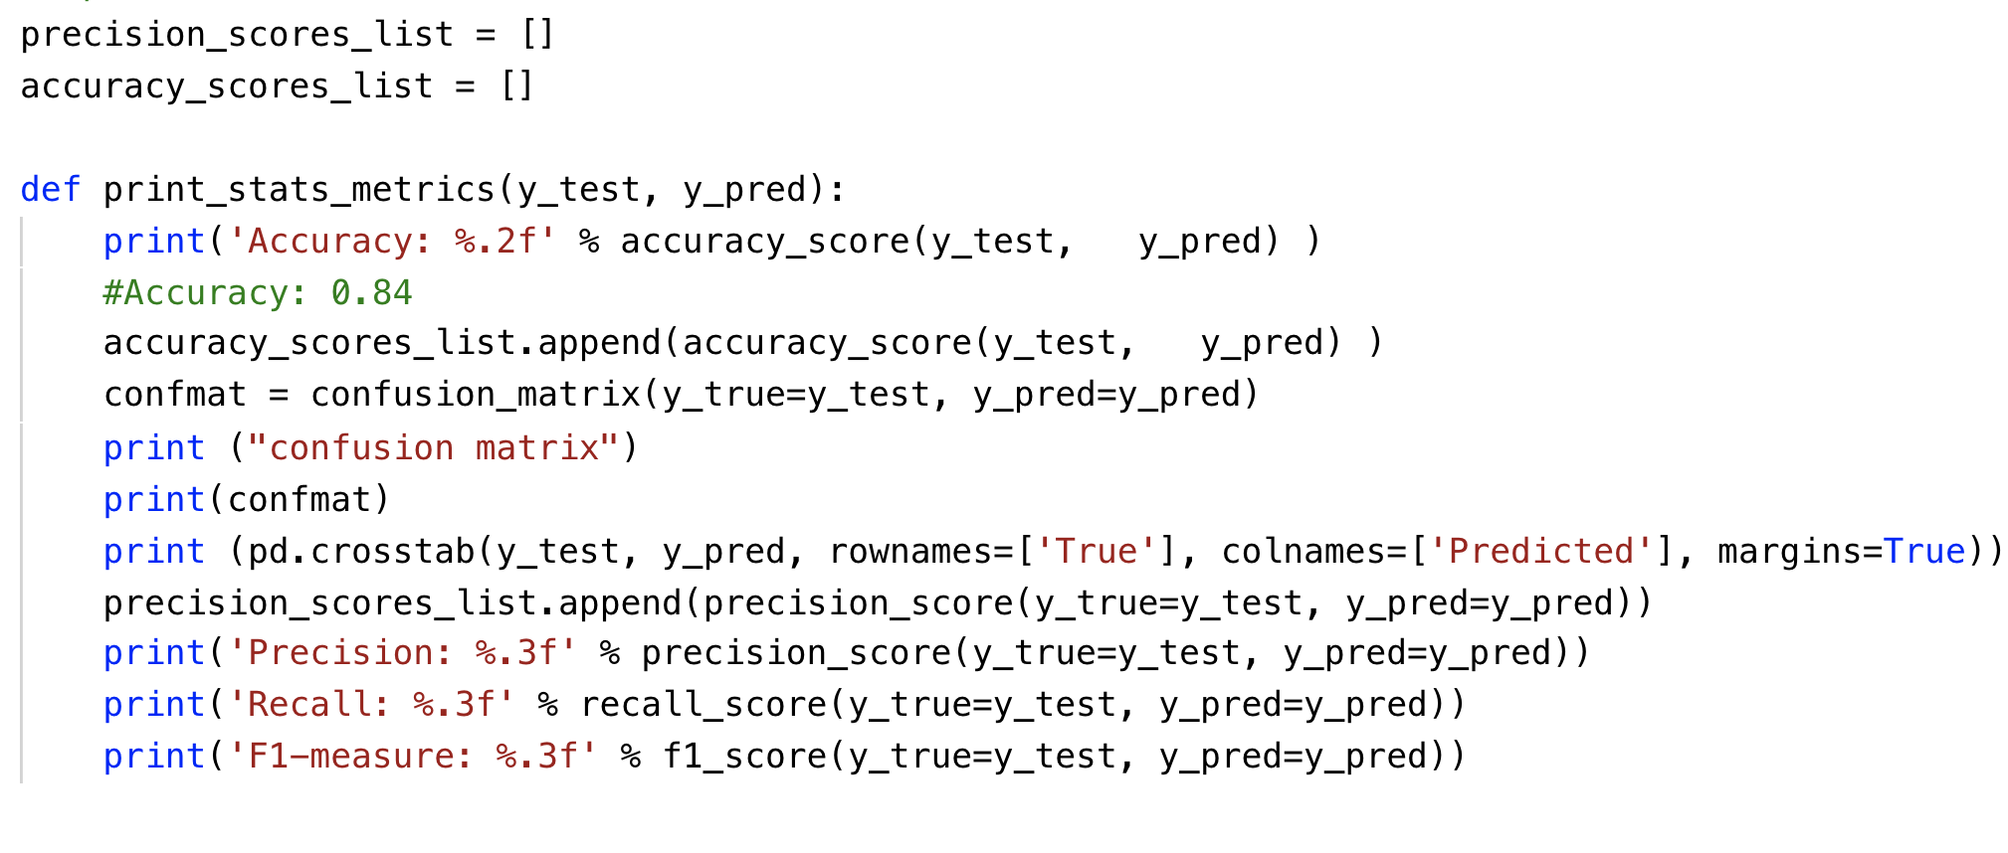
- Initialize the variables and placeholders. Then perform the training and testing on subset of kdd dataset.
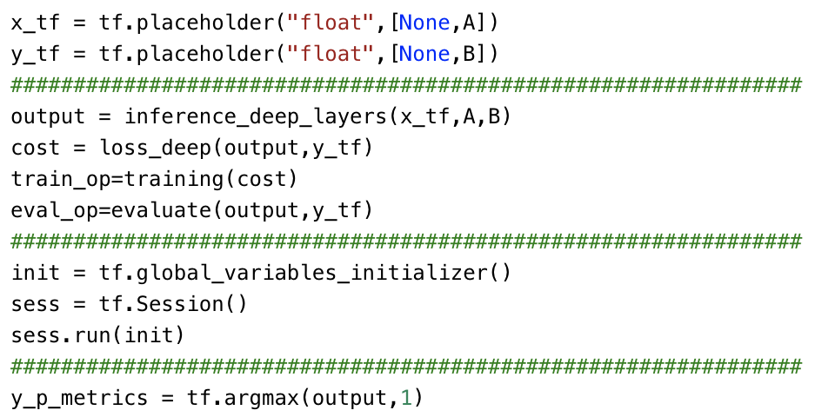

What to Submit

You should submit a lab report file which includes:
  - The steps for how you preprocessed data
  - The necessary code snippet of your classifier and architecture.
  - The screenshot of the results
  - You can name your report "Lab_kdd_yourname.doc".

