Machine learning cybersecurity

Device detection

LAB 2: Writing a cLAssifier for the device detection
Lab Description: This lab is to classify the records of packet features to predict which device send the packet.
- The dataset contains 13138 records (miscellaneous:944, camera: 8010, assistant: 2178, outlet: 1802 and mobile: 186) with 18 features for each.

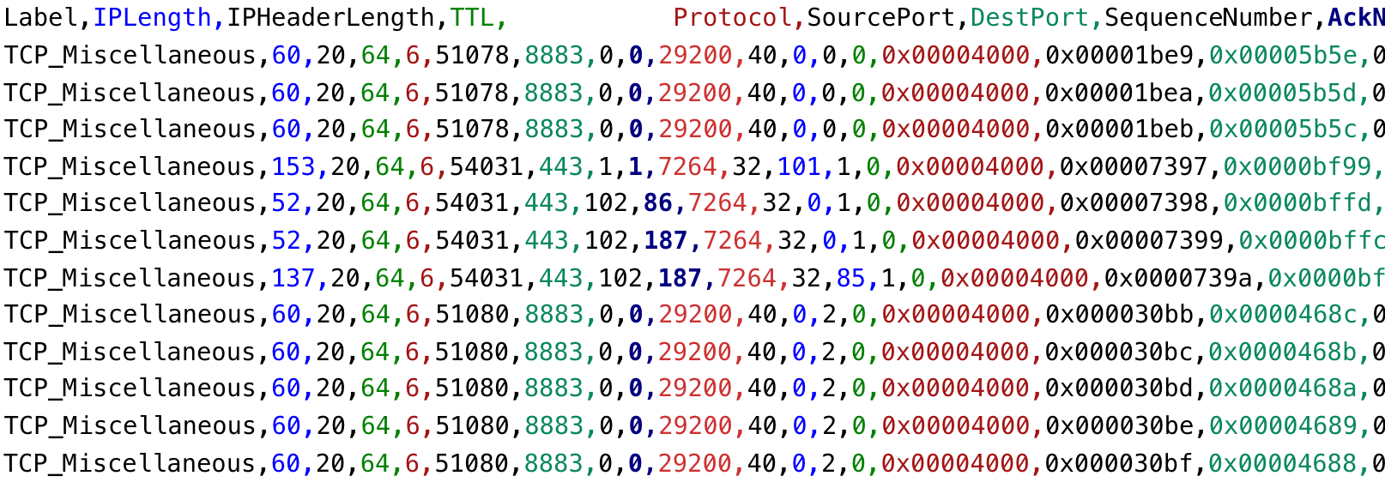
- The features and class values are both extracted from the pcap files.
- Tasks:
  - Use WEKA to input the dataset and perform the classification
  - Write a python script based on the sklearn library to implement the classifiers
  - Write a python script based on Tensorflow framework to implement the classifier.
Lab Environment:
- The students should have access to a machine with Linux system
- WEKA should be installed
- The environment for python is required as well as some packages such as numpy, tensorflow and sklearn.

Lab Files that are Needed:
- For this lab you will need only one file (label_feature_IOT.csv) for both WEKA and python scripts.
- The first column is the class value, others are the features.

Lab exercise 1
- Import data into WEKA (explorer), the files of type should be specified (csv).
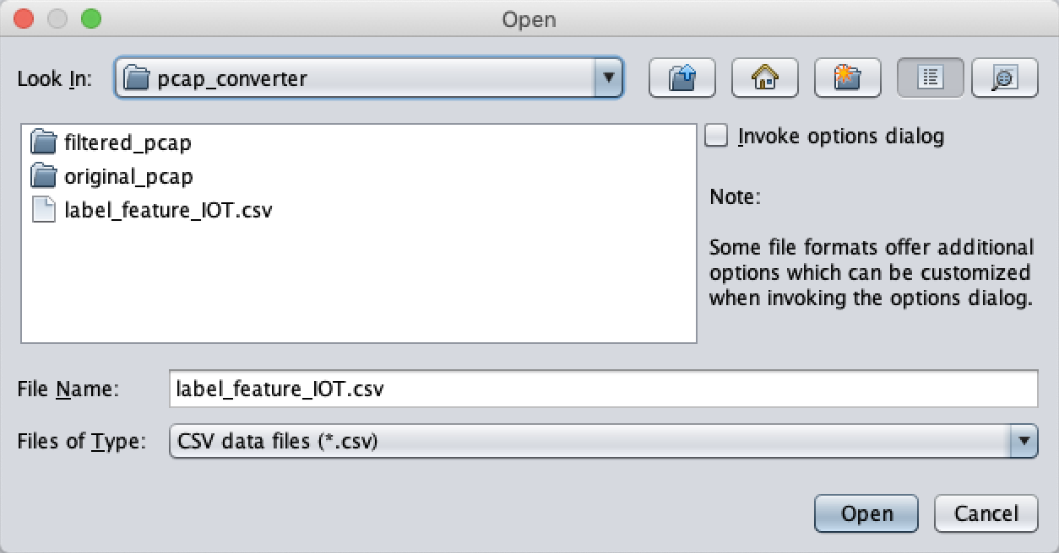
- Choose a proper classifier, such as RandomForest
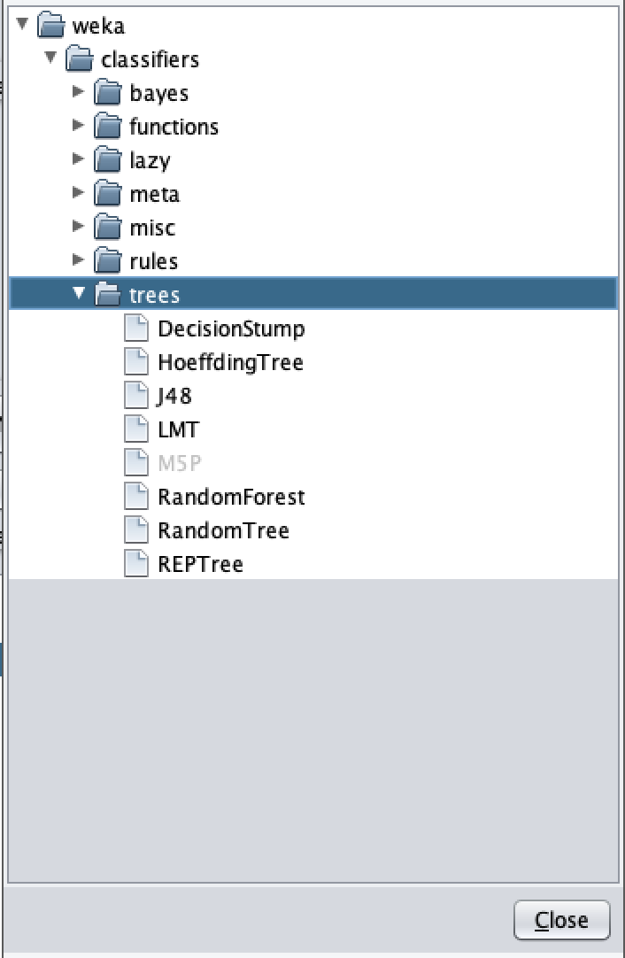
- Specify the test option and the column of class

Lab exercise 2
- In this exercise, you need to implement several classifiers with the use of sklearn.
- Import sklearn code and required libraries
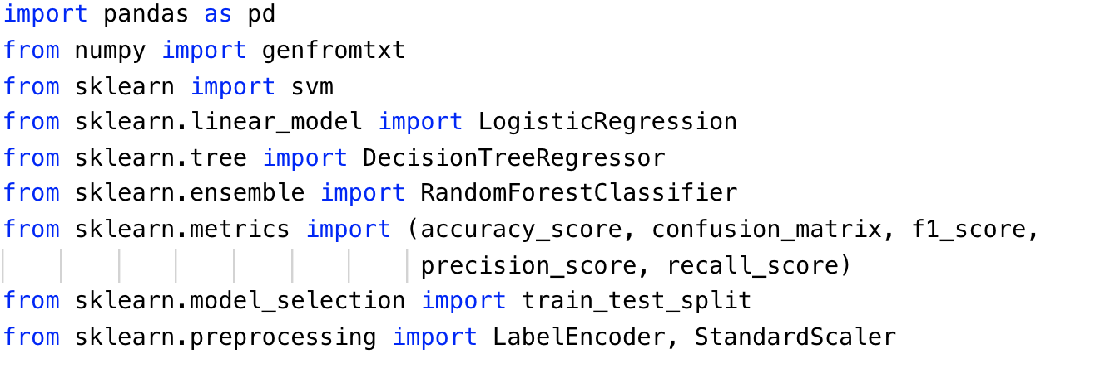
- Read the features and class values from malware dataset with proper method
- Label_feature_IOT.csv is the name of the file.
- delimiter indicates the character to split the data in a row.
- usecols indicates which columns will be read. For features, the columns from 2 to 19 will be read. For class values, the first columns of the rows will be read.
- dtype indicates the type of data to read
- Since the first line of the file is names for each column, we set skip_header to 1 to avoid read the first row.
- Since the last four columns of features are hexadecimal digits, they need to be converted to decimal digits.
The following for loop will process each value in each column.
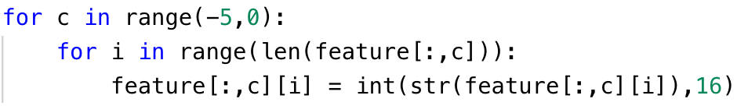
- Split the dataset. When you finish the preprocess step, you can write the python script with the use of sklearn package to build your architecture of classifier.
- random_state is the seed used by the random number generator
- This is for the decision tree:
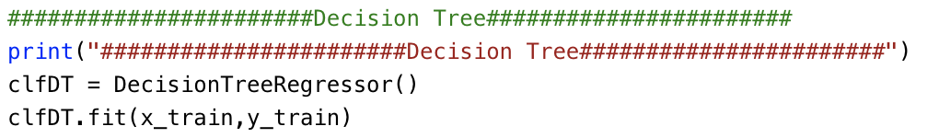
- Please print the statistics metrics such as accuracy, recall, precision and f1 score.
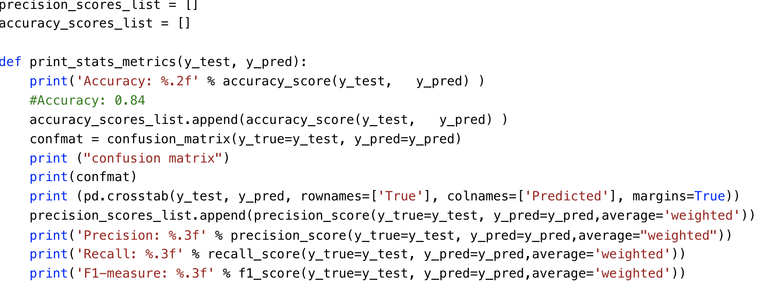
- Implement the classifiers based on Logistic Regression, Decision Tree, Naïve Bayes and Random Forest

Lab exercise 3
- Use the same data you use in the exercise 1 and 2.
- In this exercise, you will implement an artificial neural network classifier based on Tensorflow
- Import the required libraries
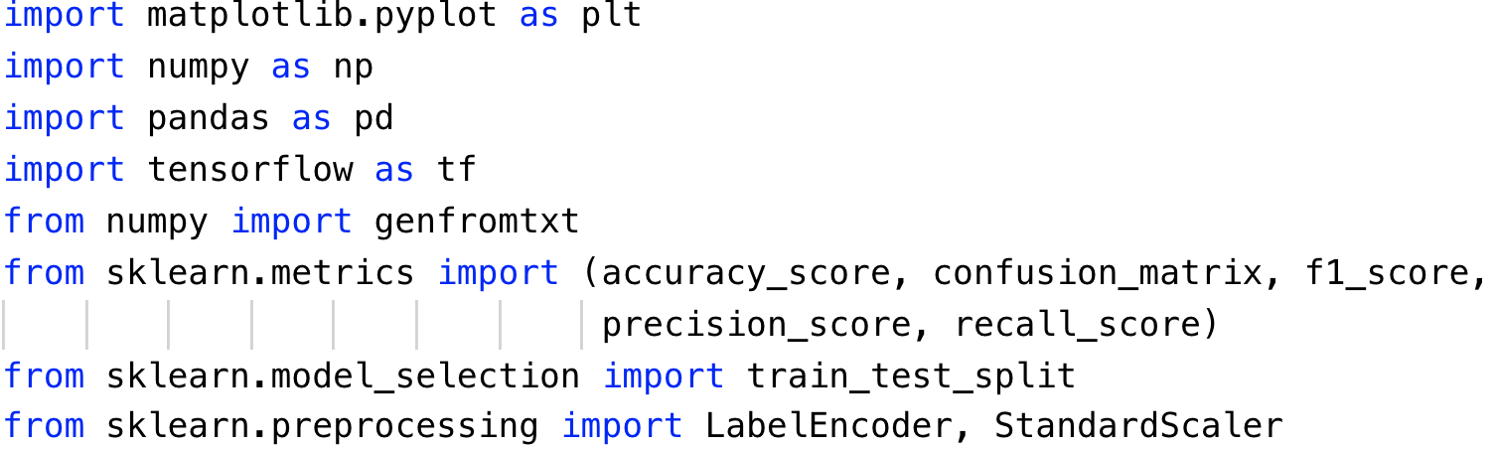
- Repeat the same steps to preprocess the data as Exercise 2. Read the data, standard scale the feature and encode the labels.
- Define the learning rate and number of epochs for artificial neural network
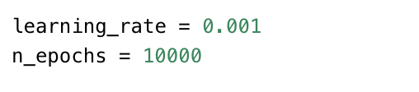
- An extra step in preprocess is to perform the one-hot encoding for the labels.
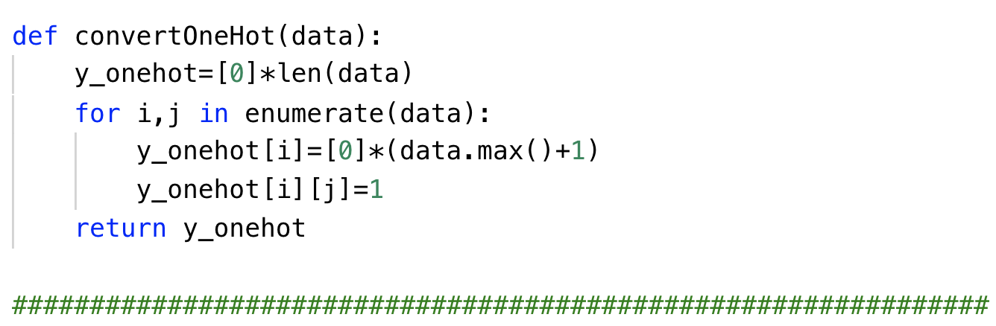
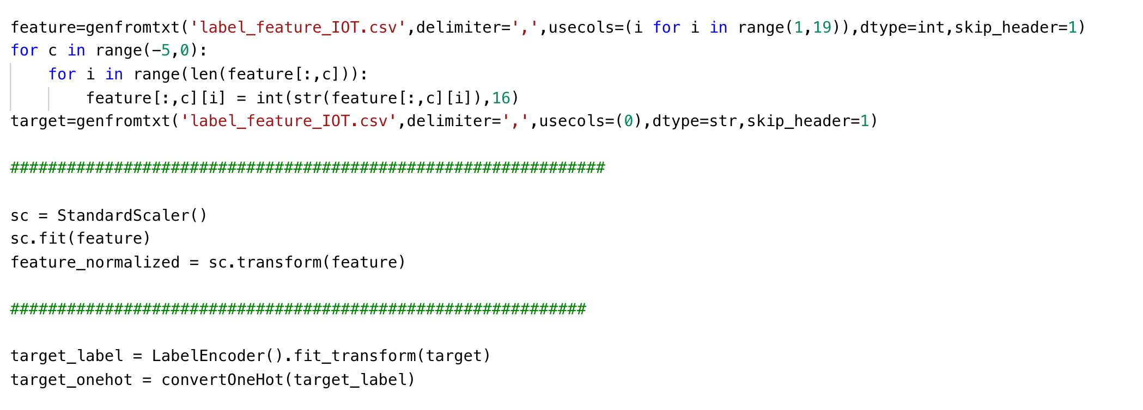
- Split the dataset after preprocessing and define the parameters to store the shape of placeholder.
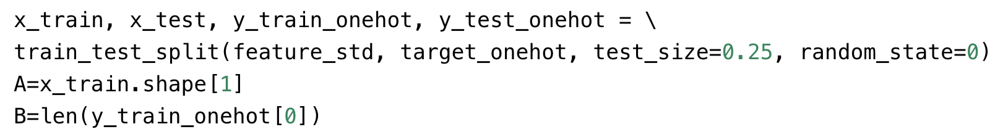
- Define the function to draw the plot of performance
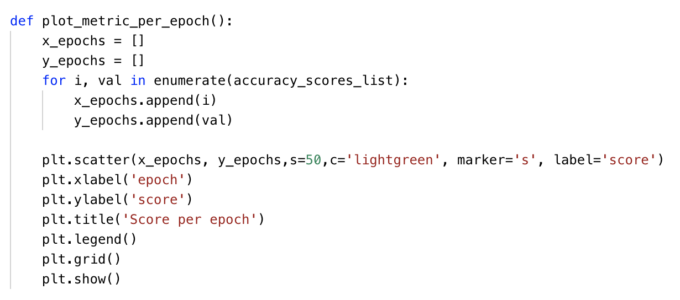
- Define your own architecture of neural network
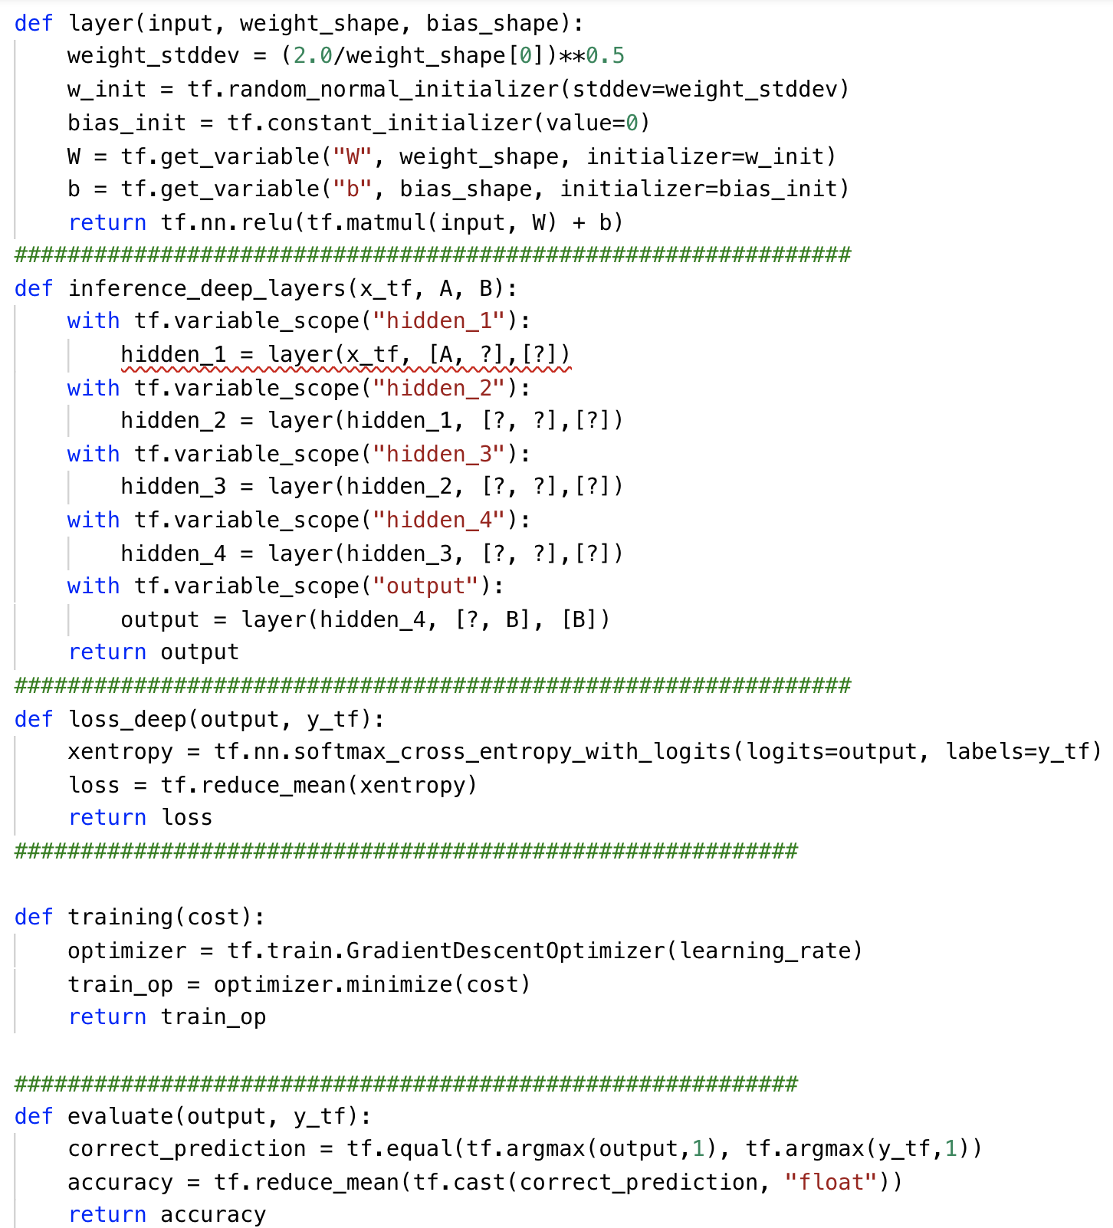
- Please print the statistics metrics such as accuracy, recall, precision and f1 score.
- Initialize the variables and placeholders. Then perform the training and testing on iris dataset.
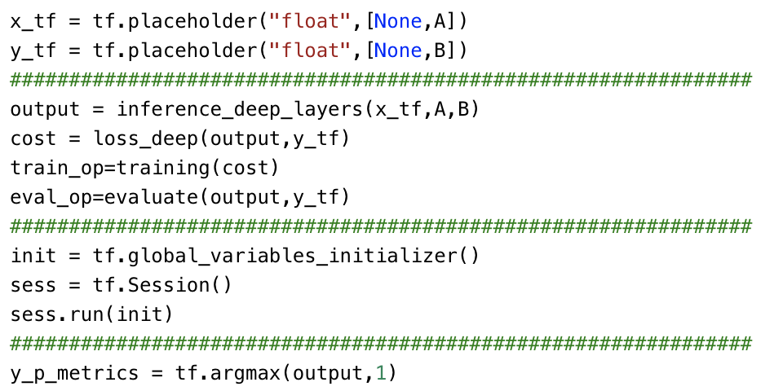

What to Submit

You should submit a lab report file which include:
- The steps you preprocessed data
- The necessary code snippet of your classifier and architecture.
- The screenshot for both your code snippet and the result are needed.
- You can call your file "Lab_IOT_yourname.doc".

