Setting up an AWS instance

- Sign-up for AWS (https://portal.aws.amazon.com/billing/signup). If you already have an AWS account, you can log in to your account.
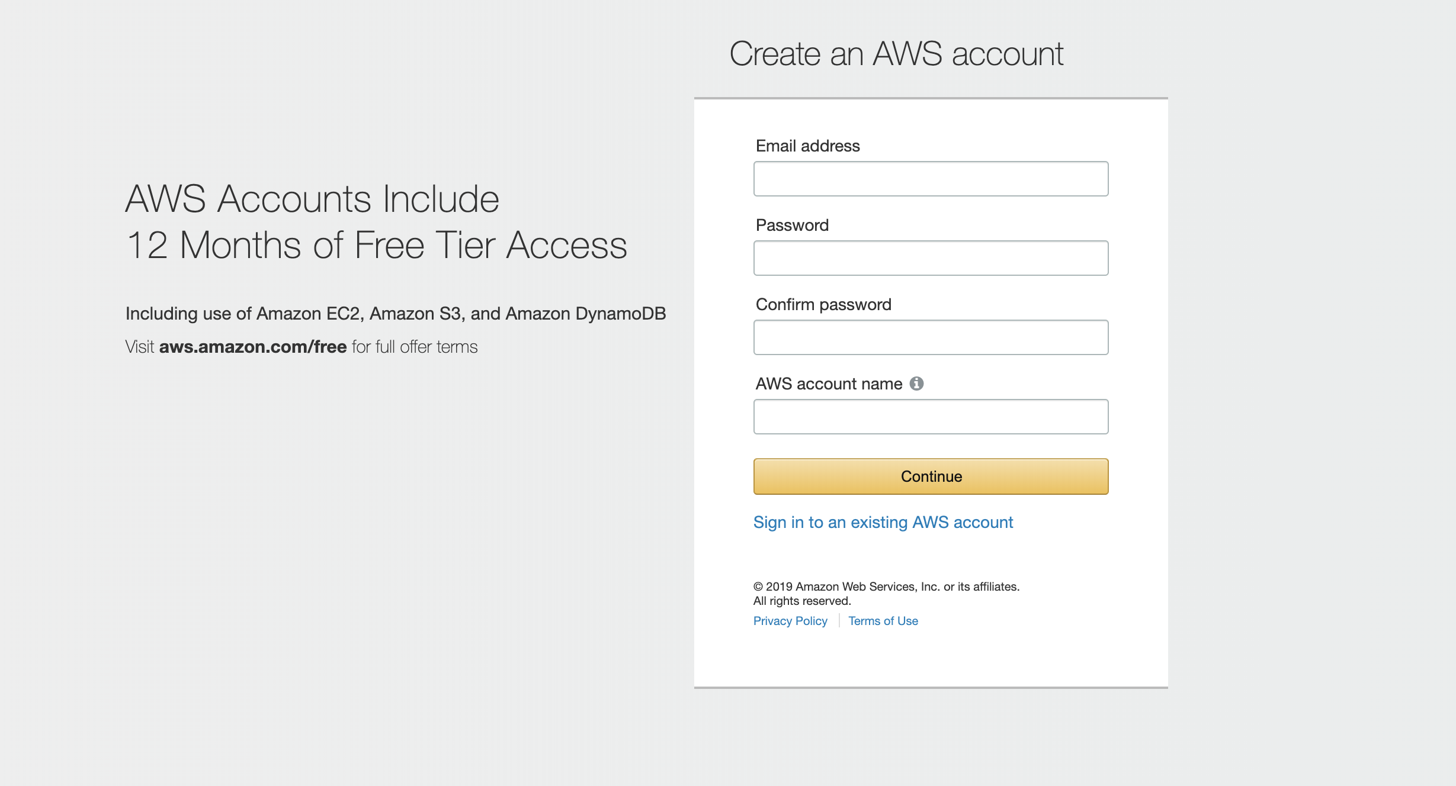
- Sign in to your account. After the payment method is set, navigate to the AWS Management Console.
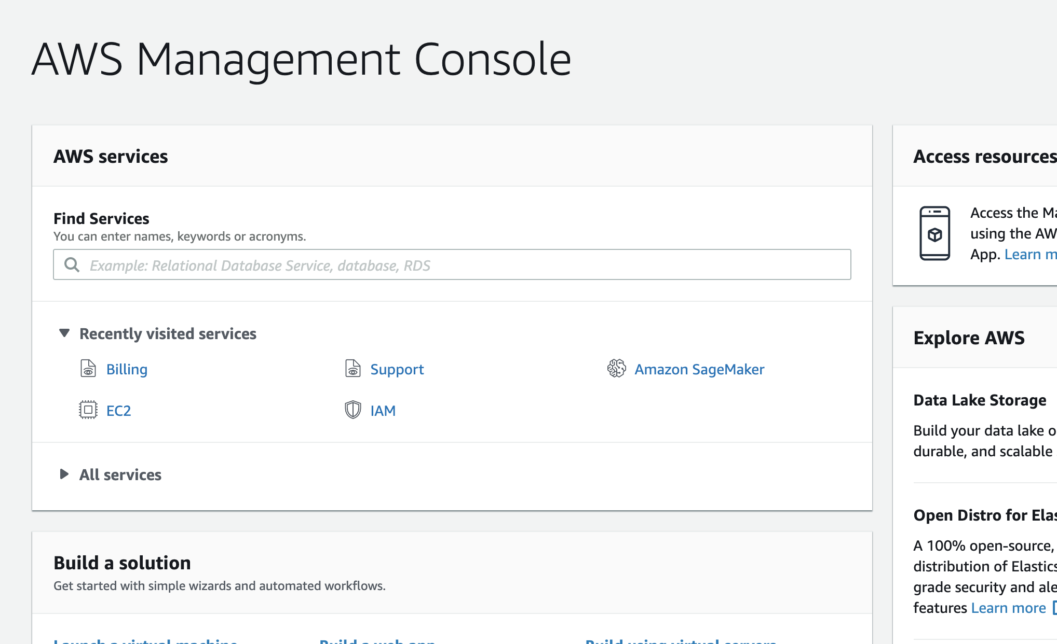
- Navigate to the EC2 console.
Type EC2 in the search bar and select EC2 to open the service console.
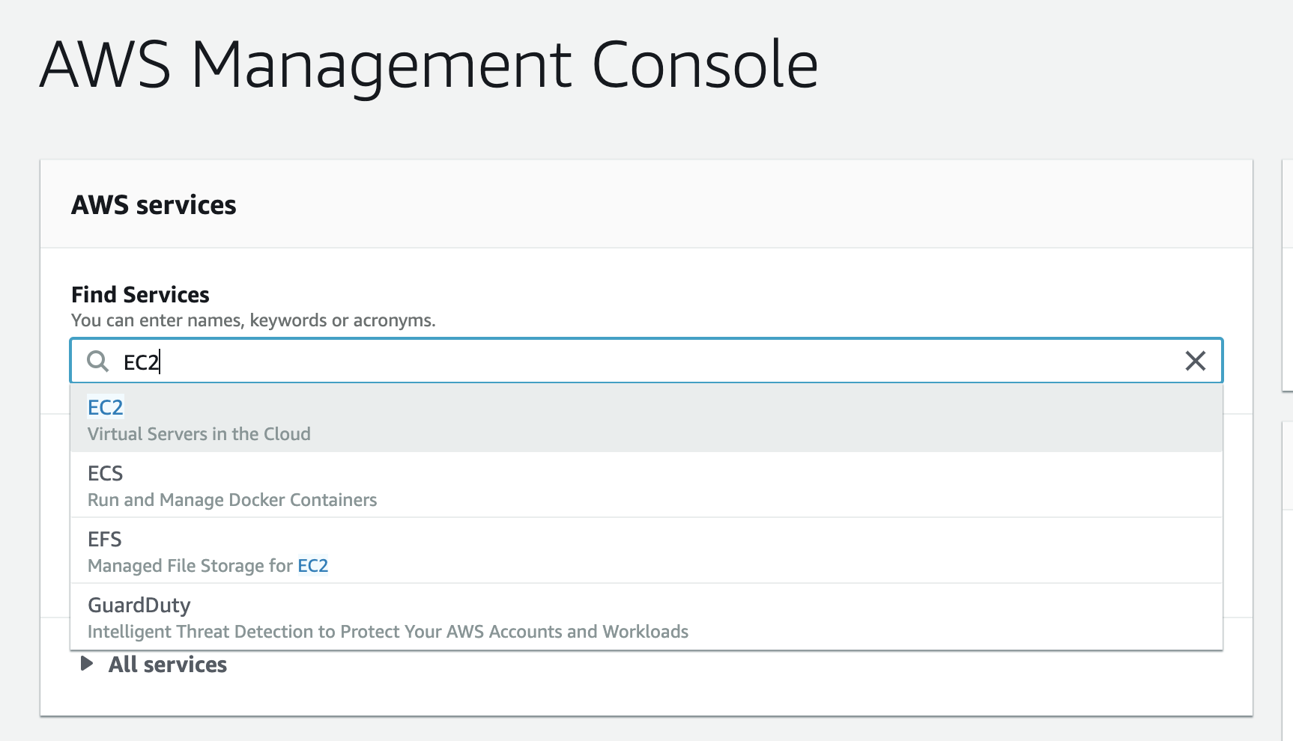
- Launch an AWS instance
Select the Launch Instance button.
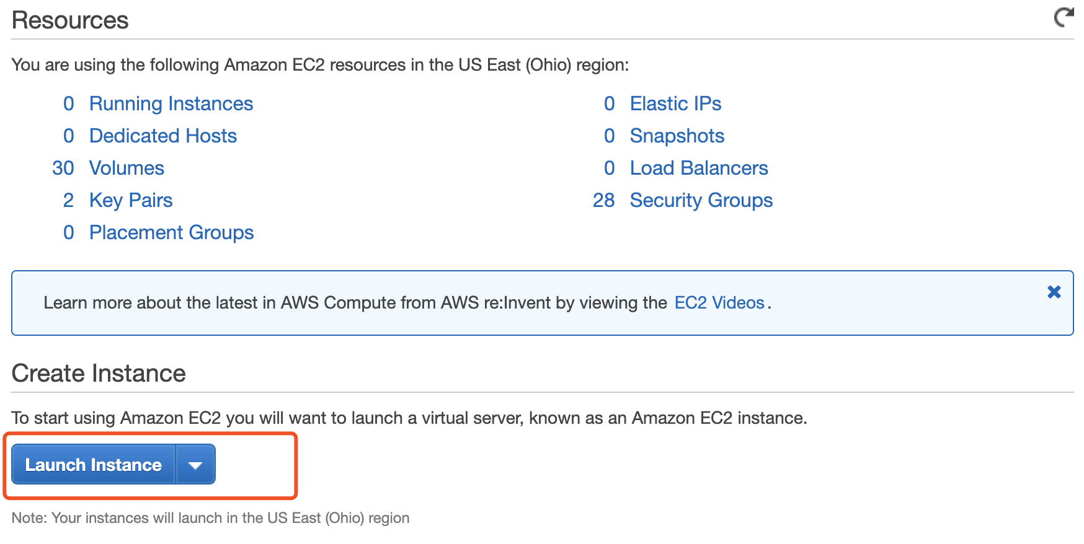
- Select the AWS Deep Learning AMI
Choose the Quick Start tab on the left, then search for ‘deep learning’. Select Deep Learning AMI (Ubuntu).
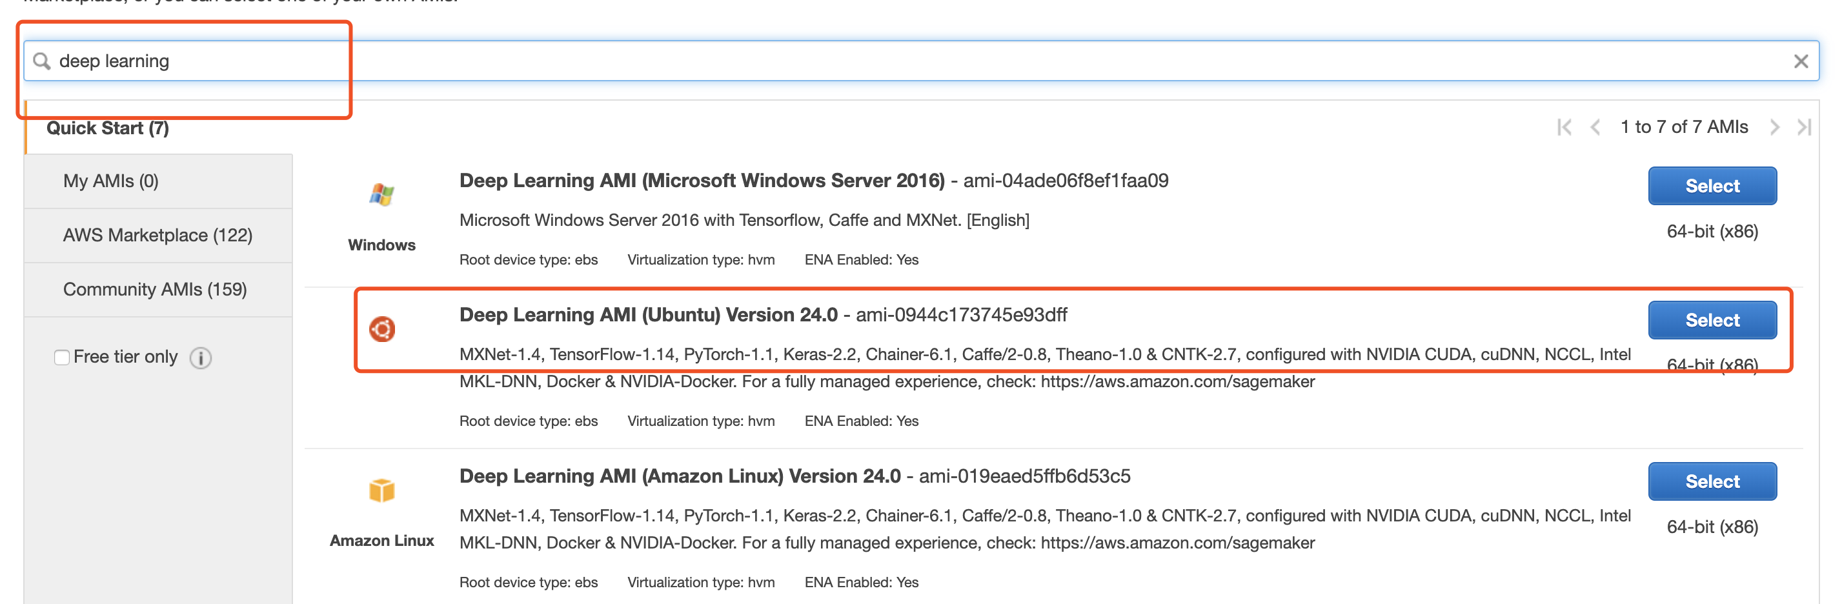

- Select the instance type
Choose an Amazon EC2 instance type. Amazon Elastic Compute Cloud (EC2) is the Amazon Web Service you use to create and run virtual machines in the cloud. AWS calls these virtual machines 'instances'.

Based on your requirement, you can choose different instance type. We will choose a GPU instance (g3s.xlarge), since we may use it for deep learning.

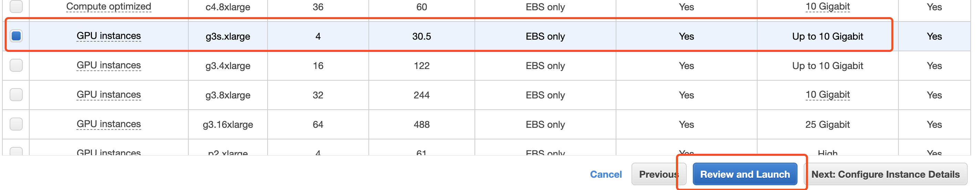

Select Review and Launch.

- Launch your instance
Review the details of your instance and select Launch.

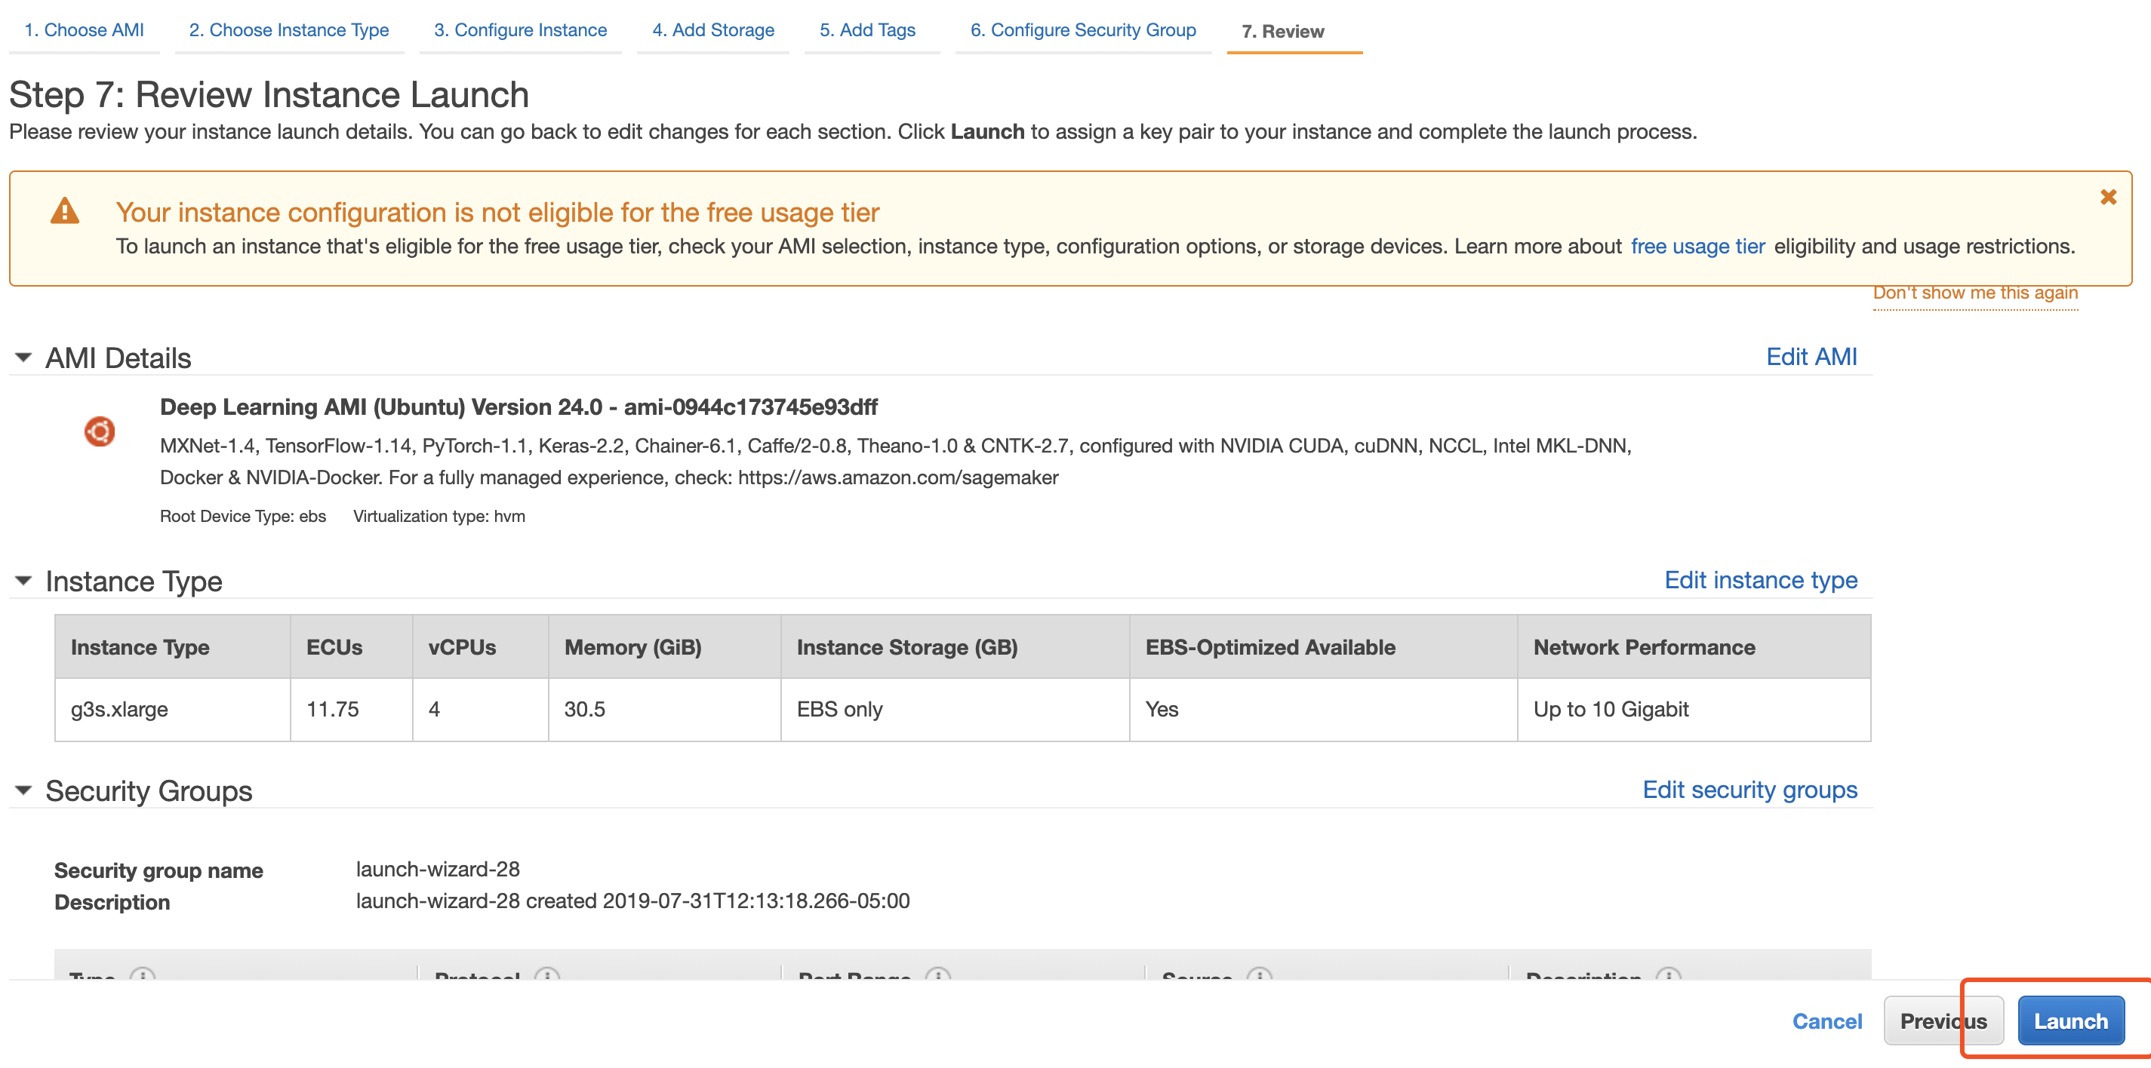
- Create a new private key file
On the next screen you will be asked to choose an existing key pair or create a new key pair. A key pair is used to securely access your instance using SSH. AWS stores the public part of the key pair which is just like a house lock. You download and use the private part of the key pair which is just like a house key.

Select Create a new key pair and give it the name. Then select Download Key Pair and you store your key in a secure location. If you lose your key, you won't be able to access your instance. If someone else gets access to your key, they will be able to access your instance.

If you have previously created a private key file that you can still access, you can use your existing private key instead by selecting Choose an existing key pair.

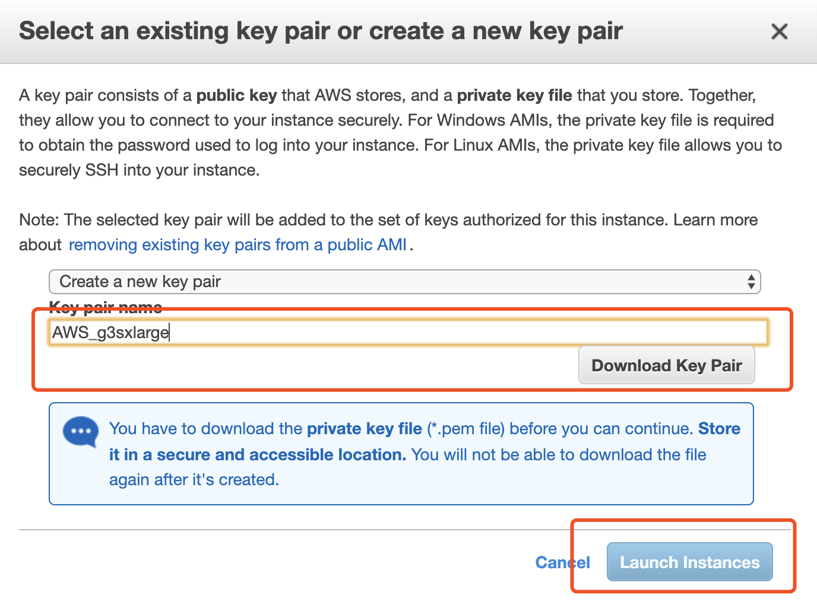
- View instance details
Select the instance ID to view the details of your newly created Amazon EC2 on the console.

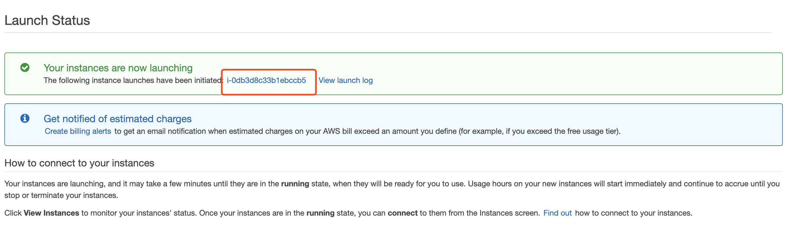
- To connect to your instance, find the Public DNS of your instance and copy it.
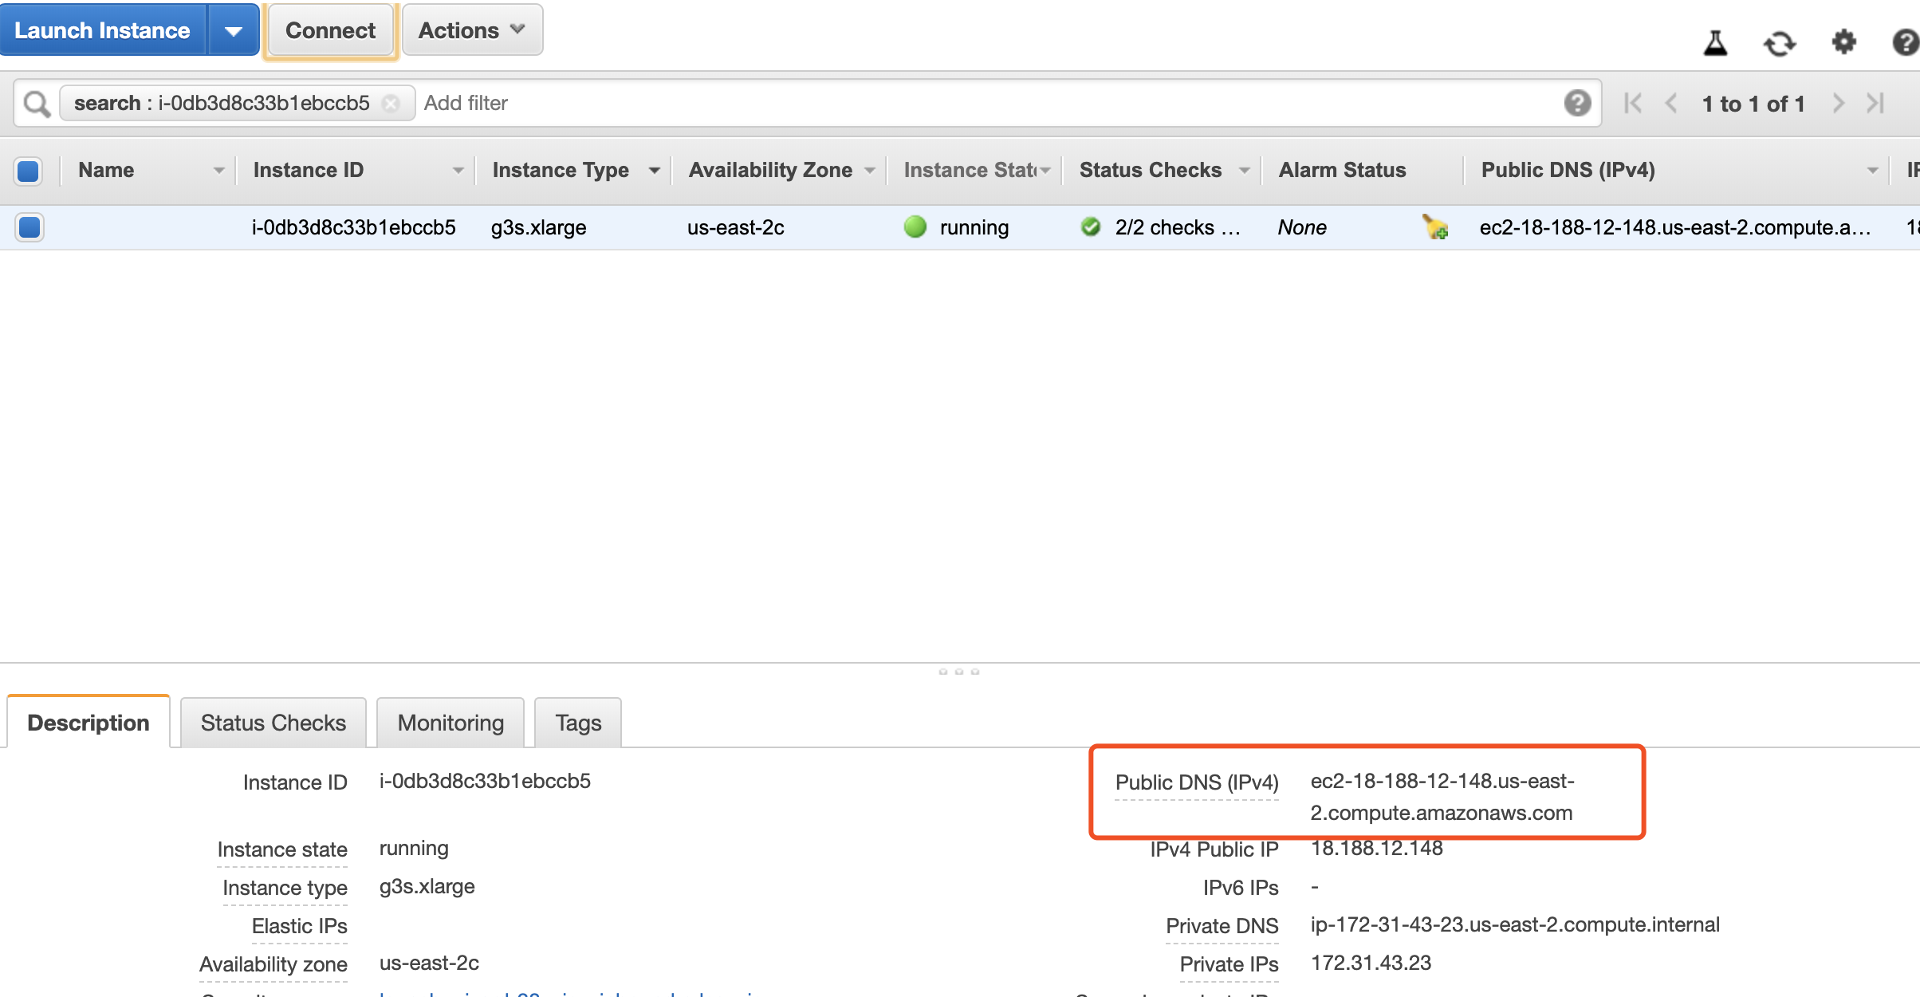

- Open your command line terminal
On your terminal, change to the directory where your security key is located, then connect to your instance with the following command.

chmod 0400 <your .pem filename>
ssh -i <your .pem filename> ubuntu@ <your instance DNS>

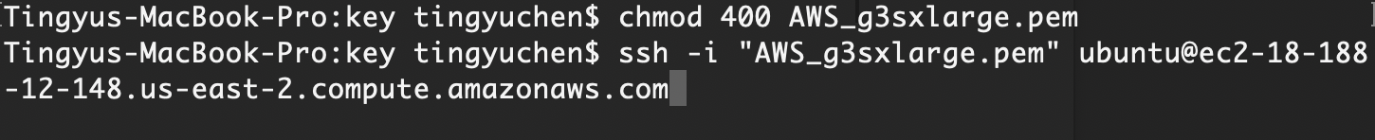

- Please use one of the following commands to start the required environment with the framework of your choice

