Machine learning cybersecurity

pcap file feature extraction

LAB 1: Writing a script to Extract features from pcap file
Lab Description: This lab is to extract features from pcap files in order to represent the raw data in the vector space model.
Example of pcap file:
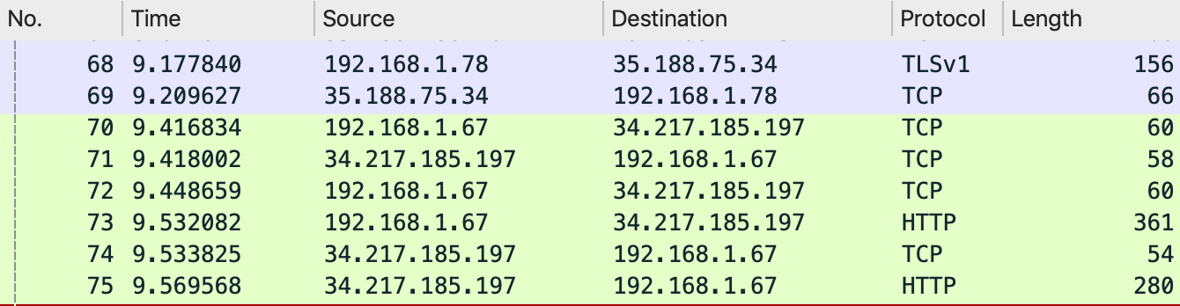
- No.: The number of the packet in the capture file
Time: The timestamp of the packet.
Source: The address where this packet is coming from.
Destination: The address where this packet is going to.
Protoco:l The protocol name in a short (perhaps abbreviated) version.
Length: The length of each packet.
- You are required to write a python script to extract features from pcap files and represent them in the vector space model.
- The labels will be assigned based on the type of devices that send the packets.
- Since we have 5 devices (assistant, camera, miscellaneous, mobile and outlet), we will create 5 labels or classes.
- We can judge the device type by the source ip address of the package:
  - Each ip address of the device is 192.186.1.#, and # is replaced by:
Assistant: 111,30,42,59,70
Camera: 128,145,78
Miscellaneous: 216,46,84,91
Mobile: 45
Outlet: 222,67
- We will extract 18 features from each of the package from the 5 devices. The 18 features are:
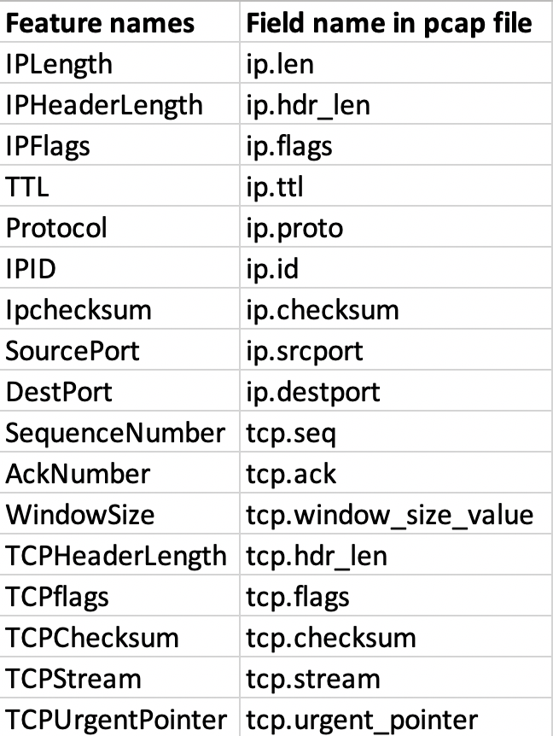
Lab Environment:
- The students should have access to a machine with Linux
- The environment for python is required as well as some libs such as numpy, tensorflow, pandas and sklearn.
- We will also need tshark.
Installation command: sudo apt install tshark

Lab Files that are Needed:
- For this lab you will need several pcap files, which are:
tcpdump-20181001-0029.pcap
tcpdump-20181001-0129.pcap
…

Lab exercise 1
- Import the required libraries.
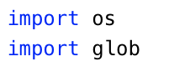
- Define a dictionary to store the string for each device you want to analyze.
  - ip_filter is the name of the dictinoary
  - 'TCP_Outlet' is the key of the filtering string for a small power outlet device
  - ' tcp && (ip.src==192.168.1.222) || (ip.src==192.168.1.67)' means to filter the tcp package from either 192.168.1.222 or 192.168.1.67, which are the ip addresses of outlet.
  - You are required to define filtering strings for the other 3 devices (Assistant, Camera, Miscellaneous)
  - Please note the single quotes and double quotes in the string

- Open a csv file to store the labels and features. The header should be the name of features and the first column should be the label.
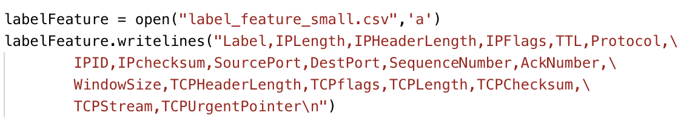

- label_feature_small.csv is the name of the file
- 'a' means append data to an existing file
- You need to write string 'label' and 18 features names into the file

- Filter out all the packets from the 5 different devices in the original pcap files and save the result into 5 new pcap files.
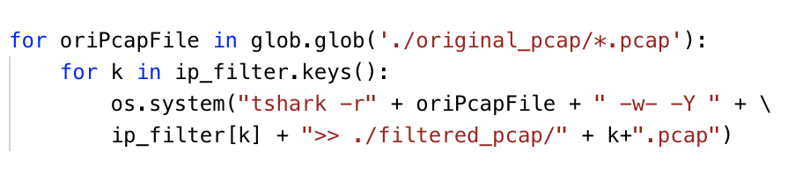
- glob.glob will process all the pcap files in the original_pcap folder
- -r means to read the local pcap file
- oriPcapFile is one of the pcap files in the original folder
- -w- and -Y means to write the packets matching the filter to the specified file
- ip_filter[k] is the filtering command for the device k
- >> will append the filtering results to the pcap files in the filtered_pcap folder
- The pcap files are named with k
- Create the labels and extract the features for them with the newly generated pcap files.
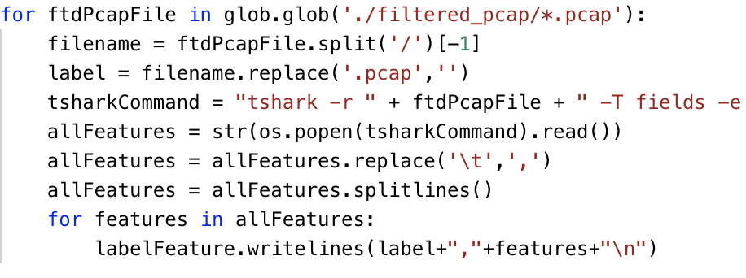
- glob.glob will get all the pcap file names in the filtered_pcap folder
- The names of the pcap files will be used to create the label
- Use tshark command to extract features from the currently processed file
- -r means to read the local pcap file
- ftdPcapFile is the name of the currently processed file
- Use several -e options for each feature (field) that you want to extract from the pcap file, such as -e ip.len
- -T option should be selected if you want to use -e option
- os.popen(tsharkCommand).read() will excute the command and save the result to the allFeatures parameter
- Before writing the label and features to the csv file, you need to convert the tab-separated results to the comma-separated results and breaking the results at line boundaries.

What to Submit

You should submit a lab report file which includes:
  - The steps for how you processed data
  - The necessary code snippet of your feature extraction script.
  - The screenshot of the results
  - You can name your report "Lab_pcap_feature_extraction_yourname.doc".

