Machine learning cybersecurity intrusion detection

LAB 1: Writing a calssifier for kdd99 DATASET
Lab Description: This lab is to implement a binary classifier to distinguish normal connections from attacks.
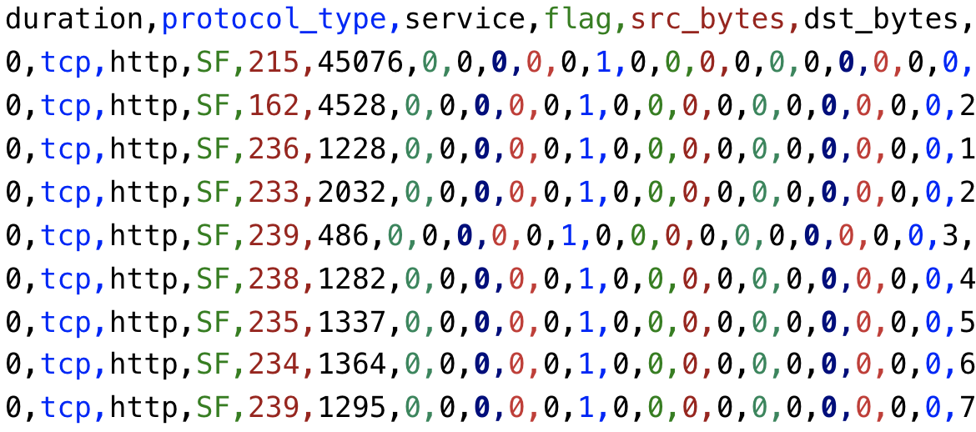
You are required to implement it in three ways:
- Using the machine learning software WEKA.
- Writing a python script with the use of the package sklearn
- Writing a python script with the use of the package tensorflow and deep learning techniques.
Lab Environment:
- The students should have access to a machine with Linux system or Windows system
- WEKA should be installed
- The environment for python is required as well as some packages such as numpy, tensorflow and sklearn.

Lab Files that are Needed:
- For this lab you will need only one file (kdd_small.csv) for both WEKA and python script.
- The last column is the class value, others are the features.

Lab exercise 1
- Import data into WEKA (explorer), the files of type should be specified (csv).
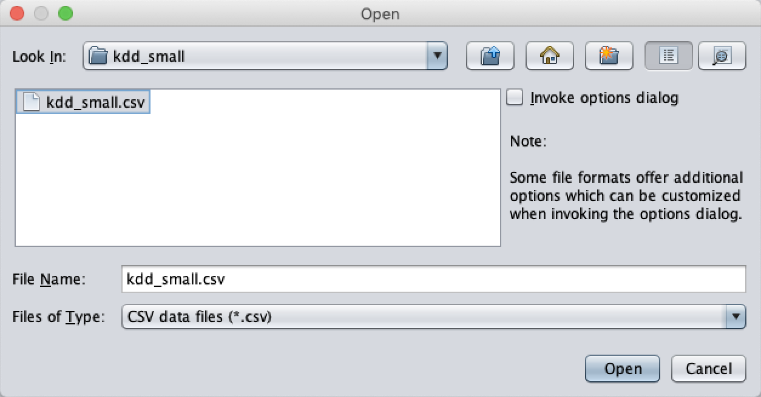
- Choose a proper classifier, such as RandomForest
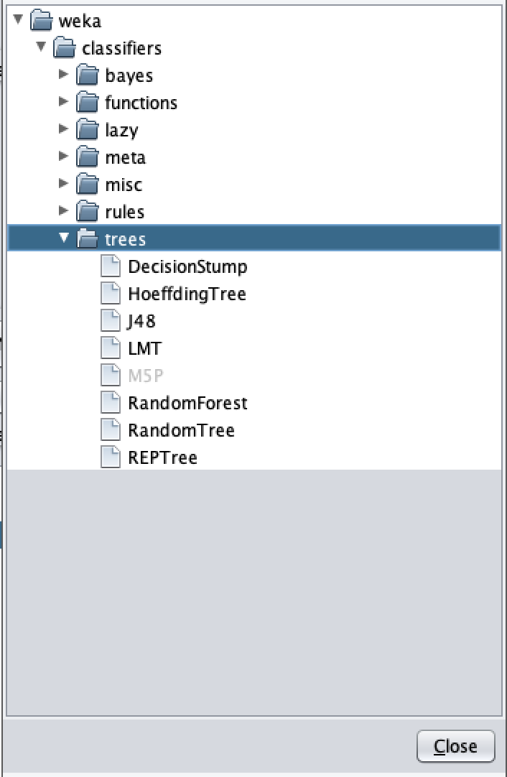
- Specify the test option and the column of class
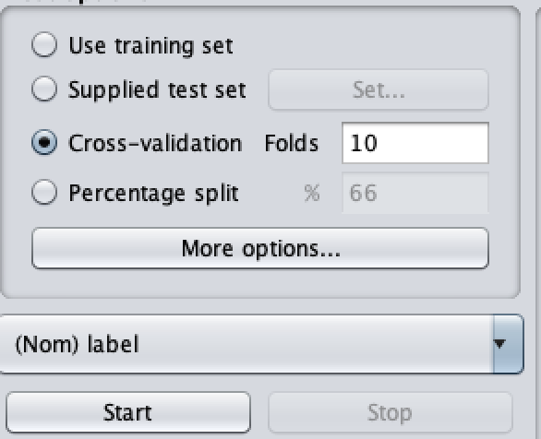

Lab exercise 2
- In this exercise, you need to implement several classifiers with the use of sklearn.
- Import the required libraries
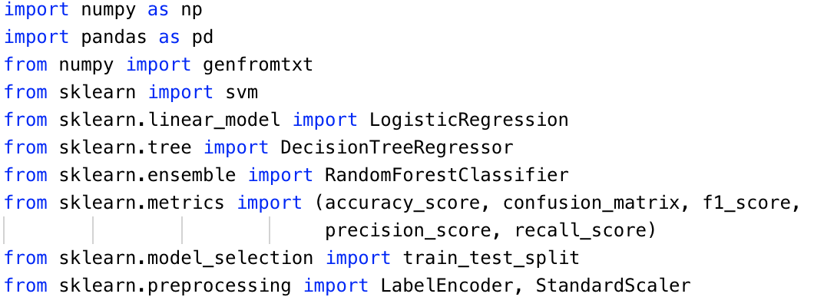
- Read the features and class values from dataset with proper method
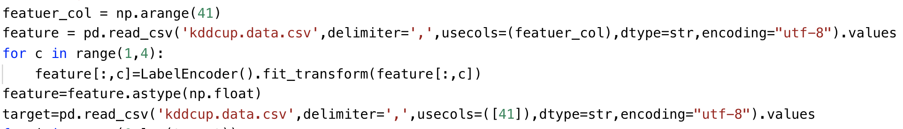
- kdd_small.csv is the name of the file.
- delimiter indicates the character to split the data in a row.
- usecols indicates which columns will be read. For features, the first 41 columns of the rows will be read. For class values, the last columns of the rows will be read.
- dtype indicates the type of data to read
- Since the first line of the file is names for each column, we set skip_header to 1 to avoid read the first row.
- Since the second to the fourth features are string type, they are transferred to float type. Also, to have a more balanced dataset, the class values of the records are defined as normal and not_normal.
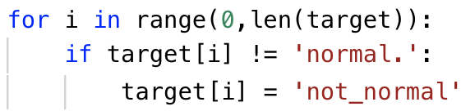
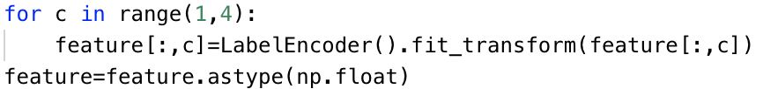
- You may need to create labels for each of kdd classes and then split the dataset. When you finish the preprocess step, you can write the python script with the use of sklearn package to build your architecture of classifier.
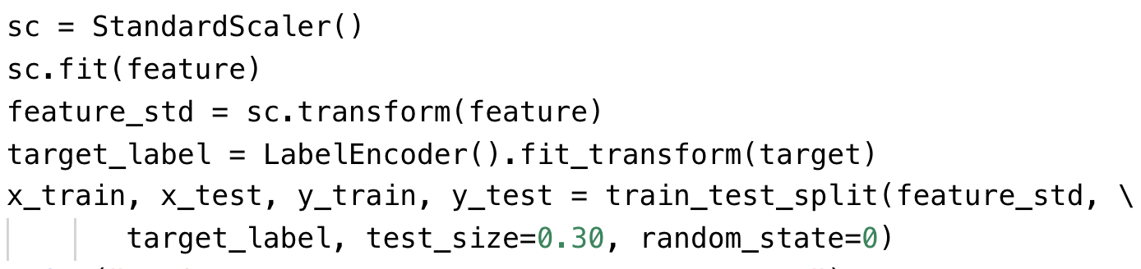
- random_state is the seed used by the random number generator
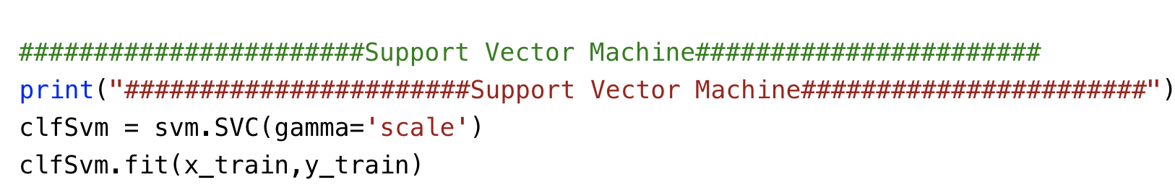
- Please print the statistics metrics such as accuracy, recall, precision and f1 score.
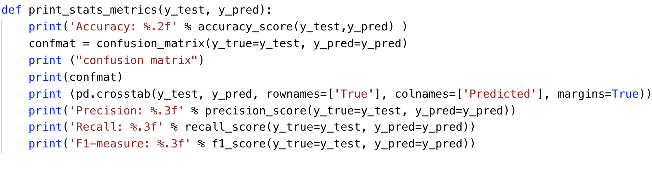
- Implement the classifiers based on Logistic Regression, Decision Tree, Support Vector Machine and Random Forest

Lab exercise 3
- Use the same data you use in the exercise 1 and 2.
- In this exercise, you will implement an artificial neural network classifier based on Tensorflow
- Import the required libraries
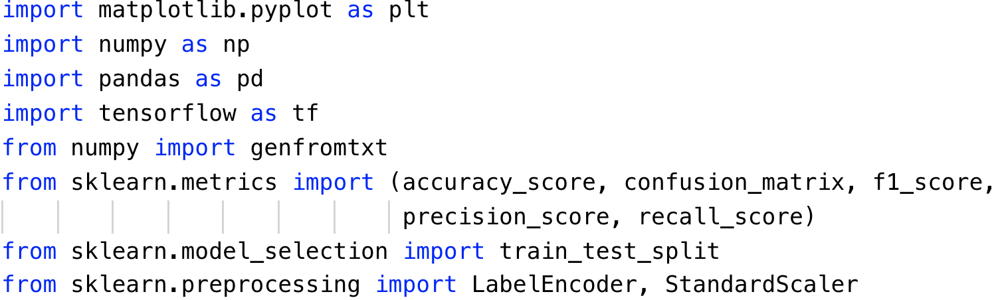
- Repeat the same steps to preprocess the data as Exercise 2. Read the data, standard scale the feature and encode the labels.
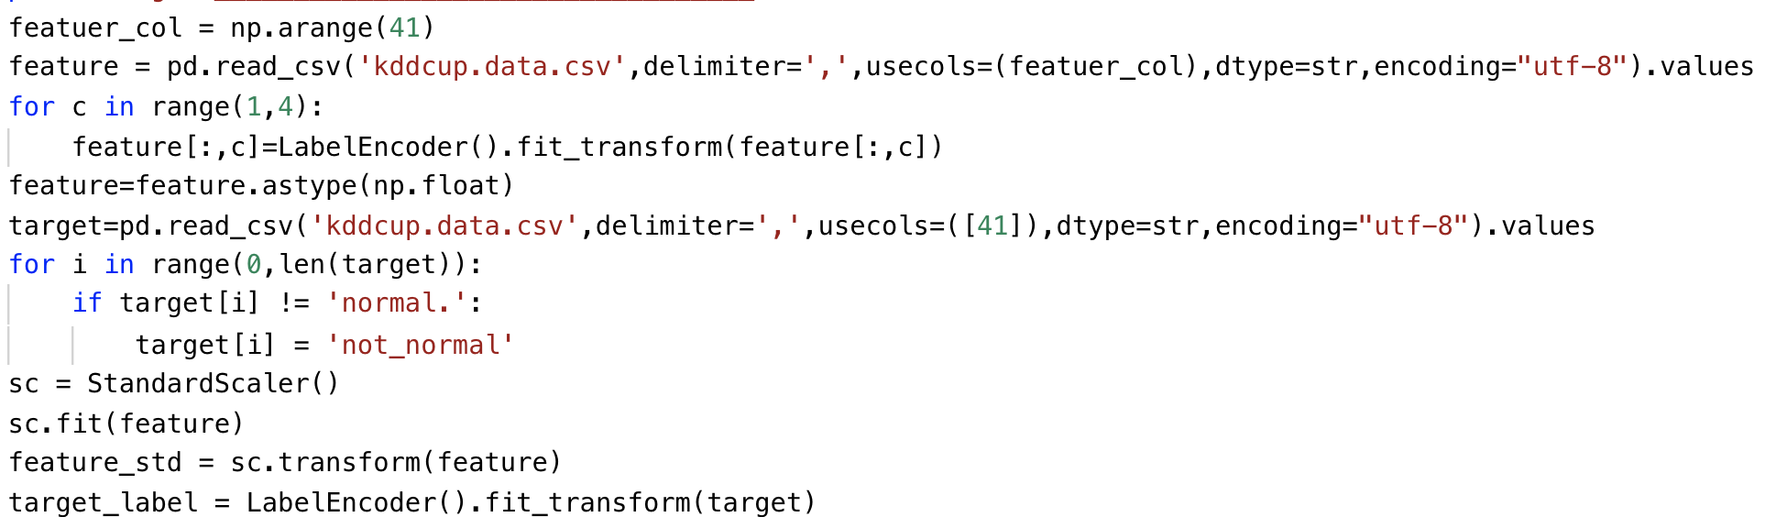
- Define the learning rate, number of epochs and batch size for artificial neural network
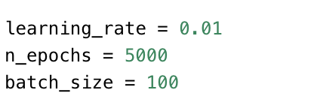
- An extra step in preprocess is to perform the one-hot encoding for the labels.
Since the type of result of tf.one_hot is a tensor object, it has to be converted to a numpy array.
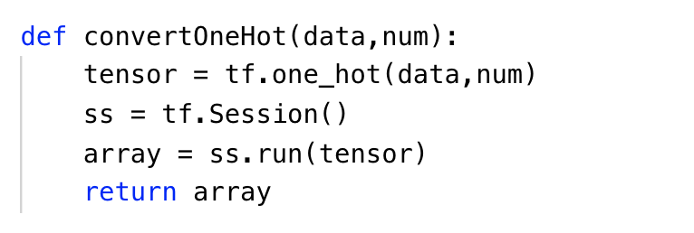

- Split the dataset after preprocessing and define the parameters to store the shape of placeholder.
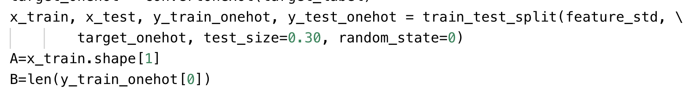
- Define the function to draw the plot of performance
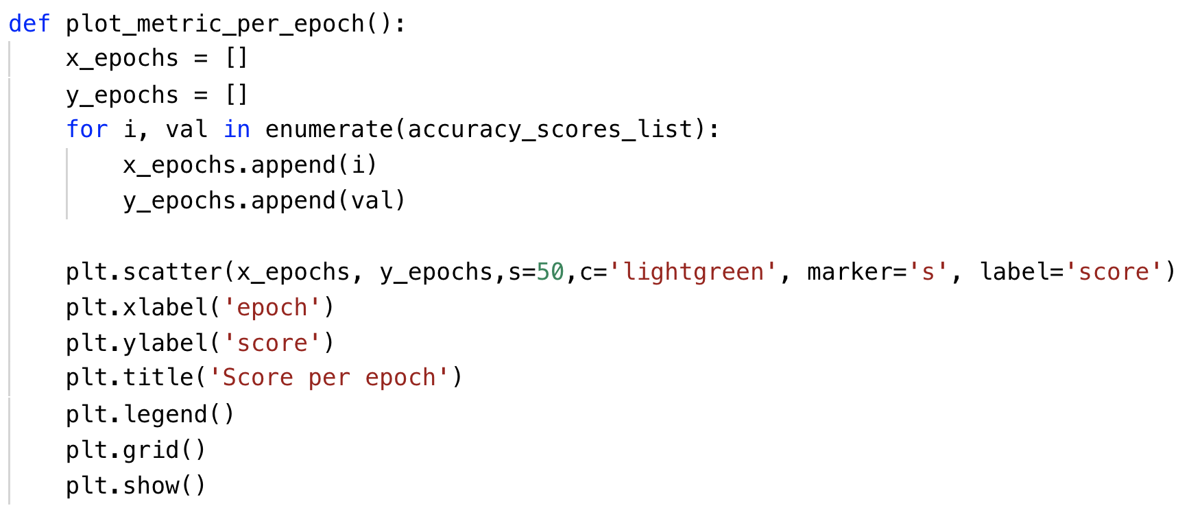
- Define your own architecture of neural network
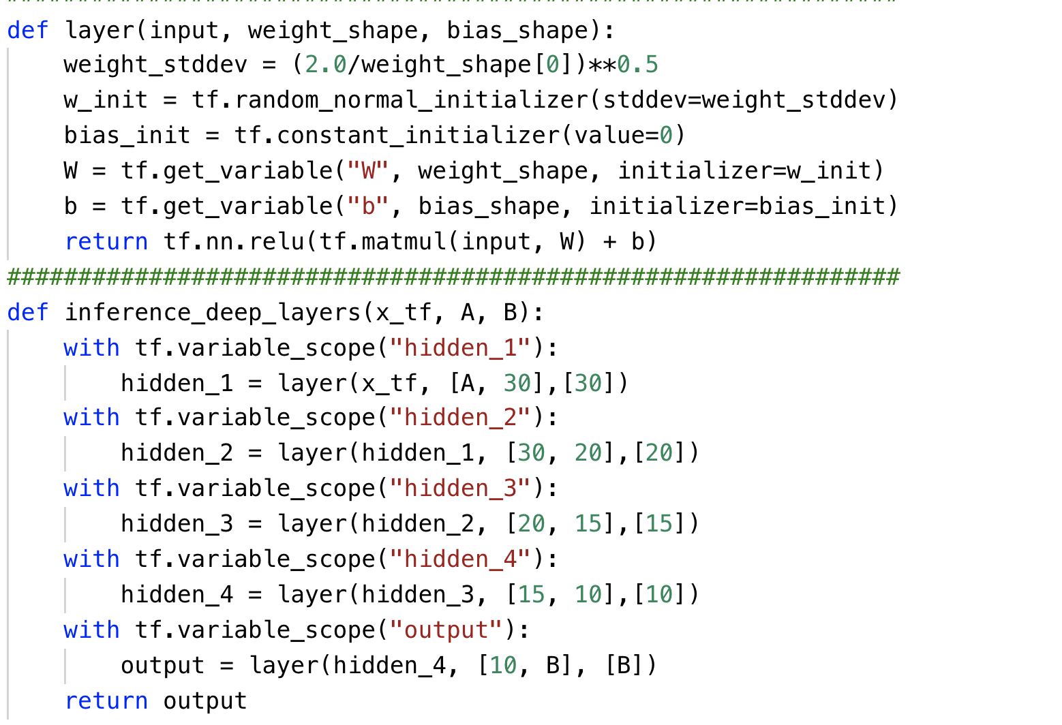
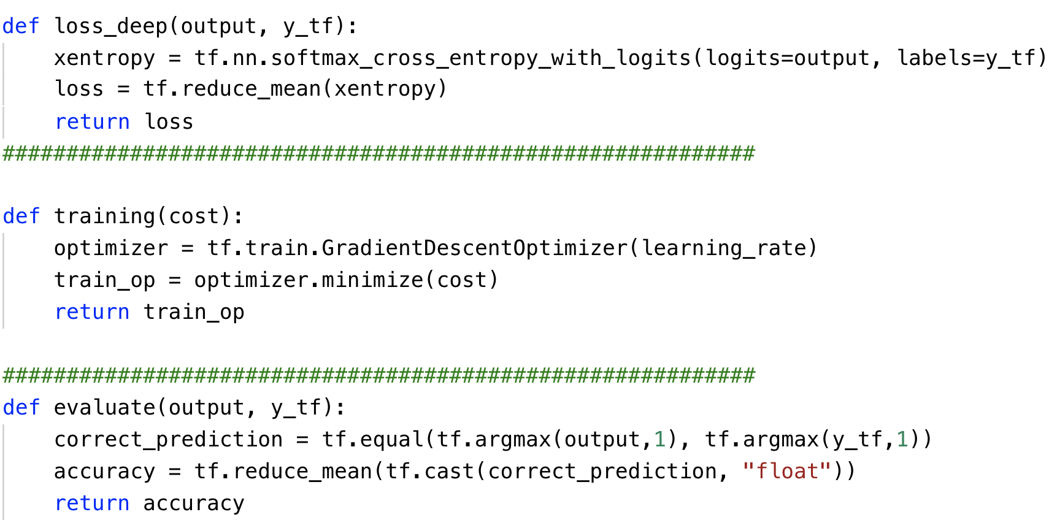
- Please print the statistics metrics such as accuracy, recall, precision and f1 score.
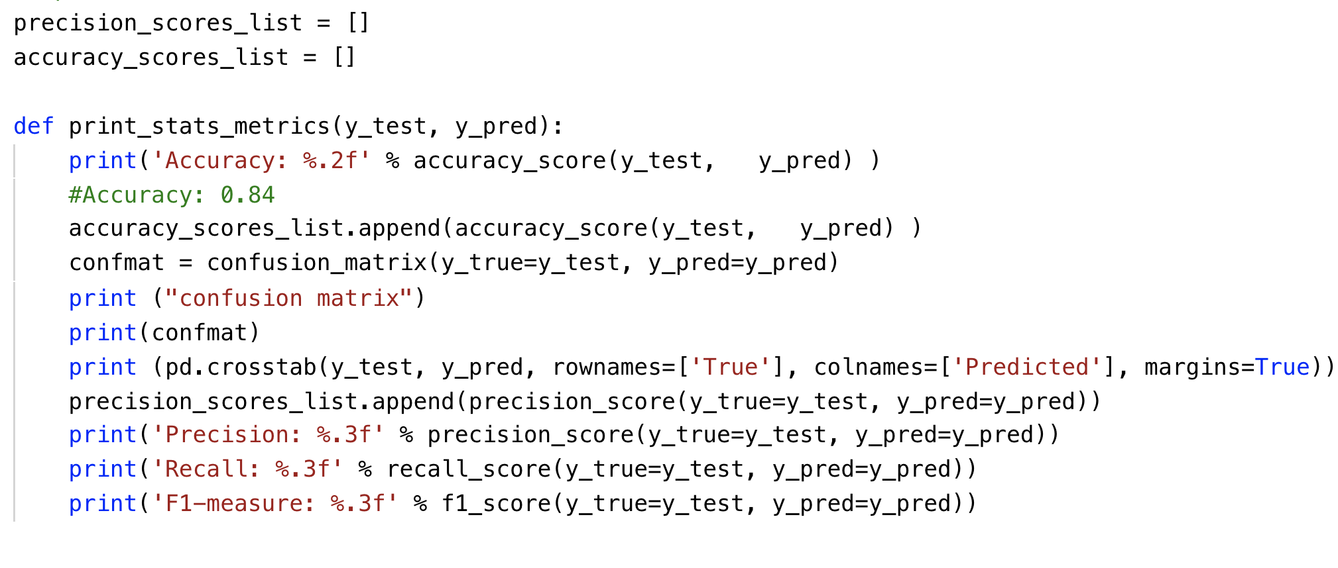
- Initialize the variables and placeholders. Then perform the training and testing on subset of kdd dataset.
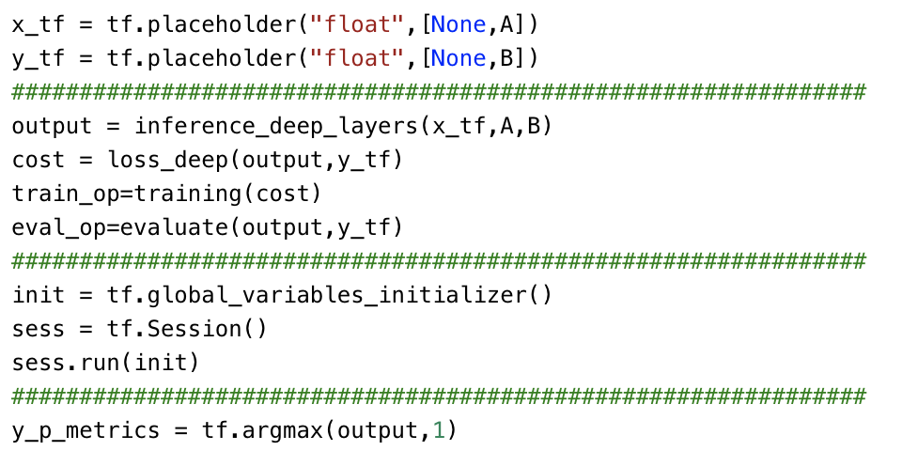

What to Submit

You should submit a lab report file which includes:
  - The steps for how you preprocessed data
  - The necessary code snippet of your classifier and architecture.
  - The screenshot of the results
  - You can name your report "Lab_kdd_yourname.doc".

